Cloud and Mobile Computing: Experiencing Microsoft Azure

April 26, 2021

Wujian Xue

**1.Go to https://azure.microsoft.com/ or https://aws.amazon.com/**

In this article, I choose Microsoft Azure to experience cloud computing. On the front page, Azure clearly states that it offers $200 credit for new users.

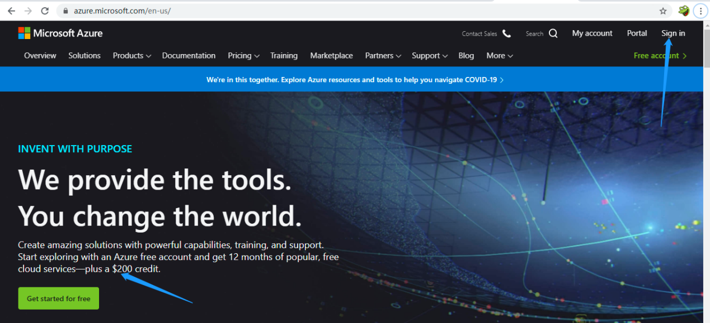

Since I have registered in Azure before, I can just click on Sign in. As a matter of fact, I have more than one accounts in Azure. I use my email sign in this time.

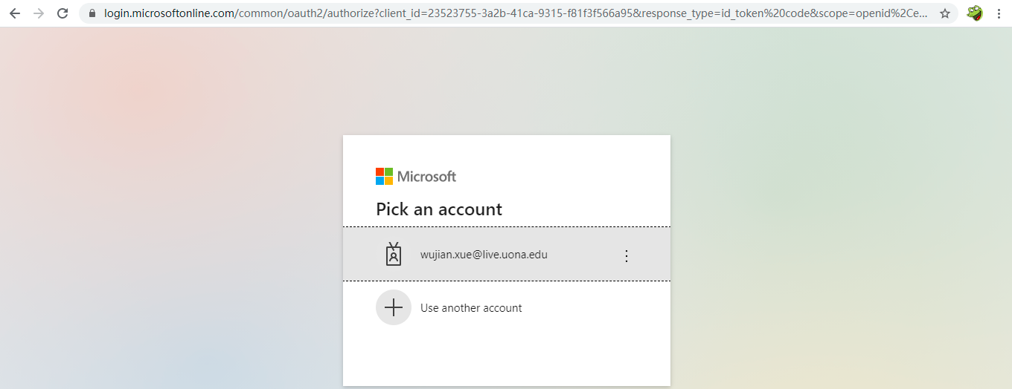

**2.Create your free personal cloud service subscription.**

This is the page after I signed in.

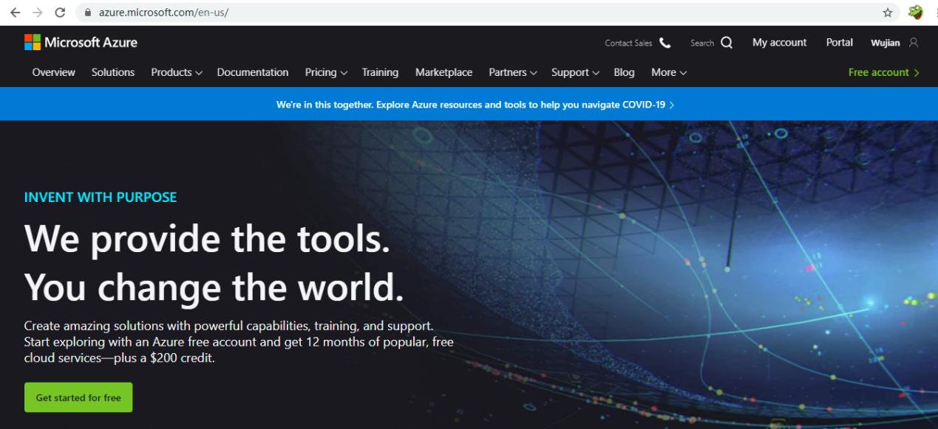

When I registered with my email, Azure offered me $100 credit for student account. I used $23 and there are $77 left.

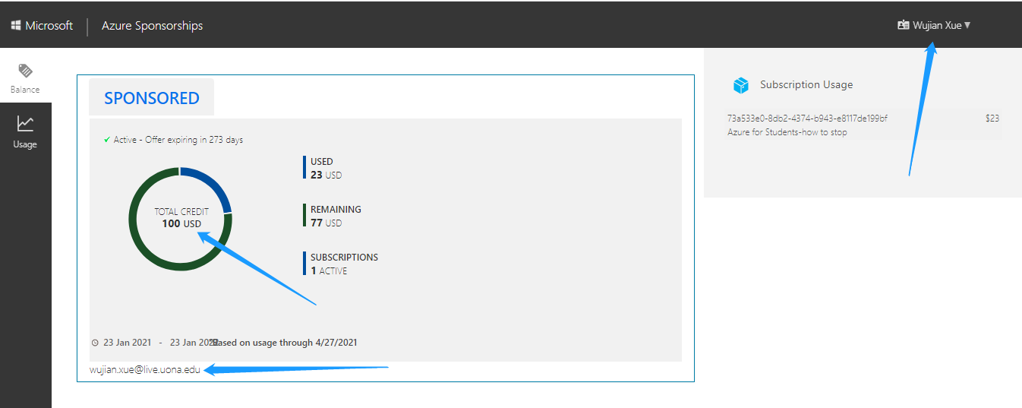

**3.Make screenshot showing you are the owner of the account.**

This page shows I’m the owner of the account too, as you can see my name and email. I practiced Azure about 2 month ago for Machine Learning models.

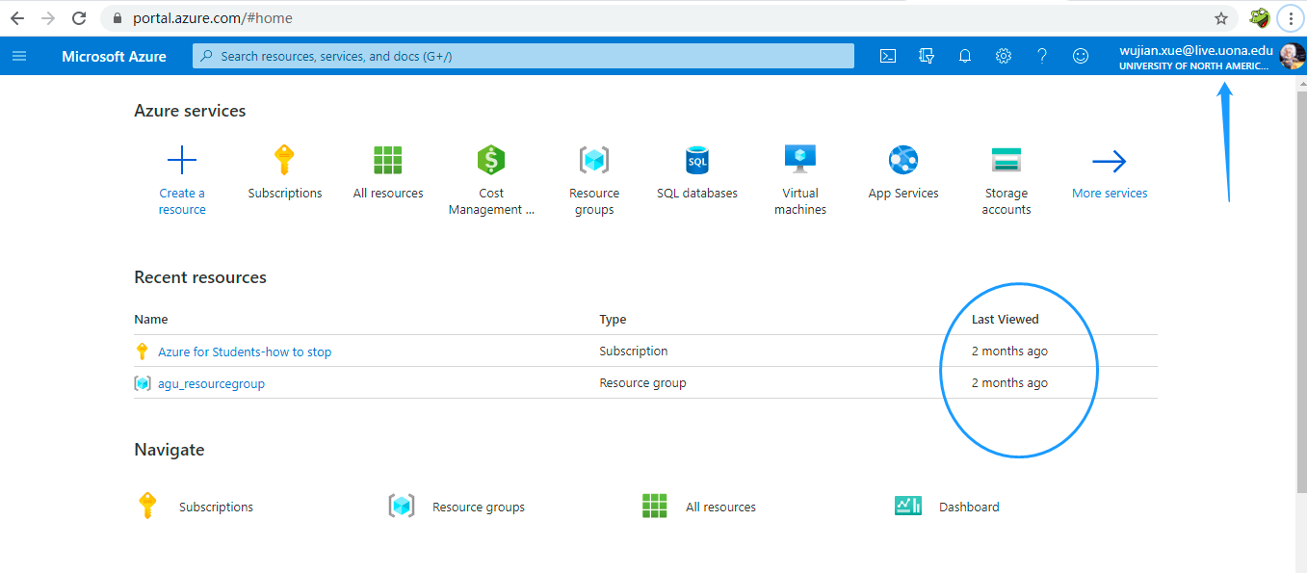

**4.Find some interesting feature such as creating virtual machine, or something else you would like to try.**

I’d like to try machine learning feature on Azure in this section. First of all, I need to create an Azure Machine Learning workspace.

Create a resource

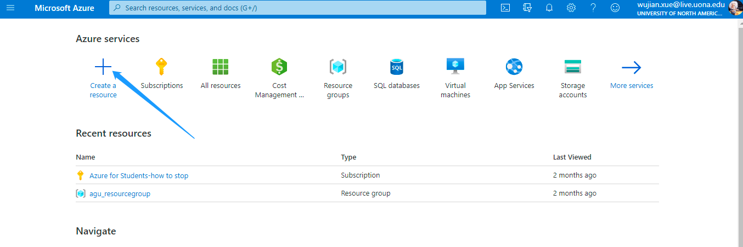

Search for machine learning

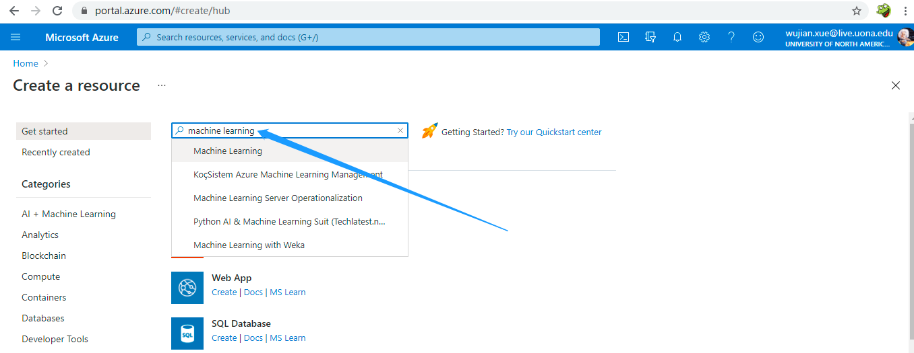

Create a new Machine Learning resource

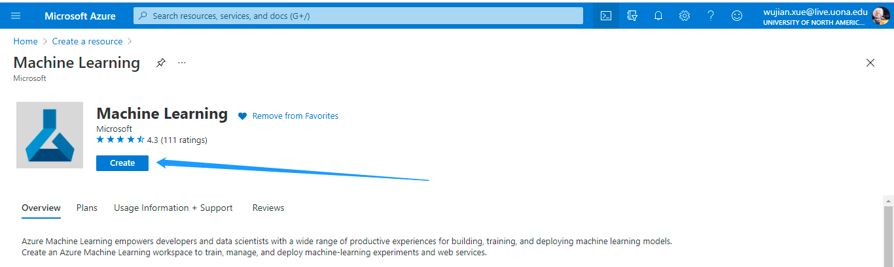

Set Parameters: Workspace Name, Subscription, Resource group, Location

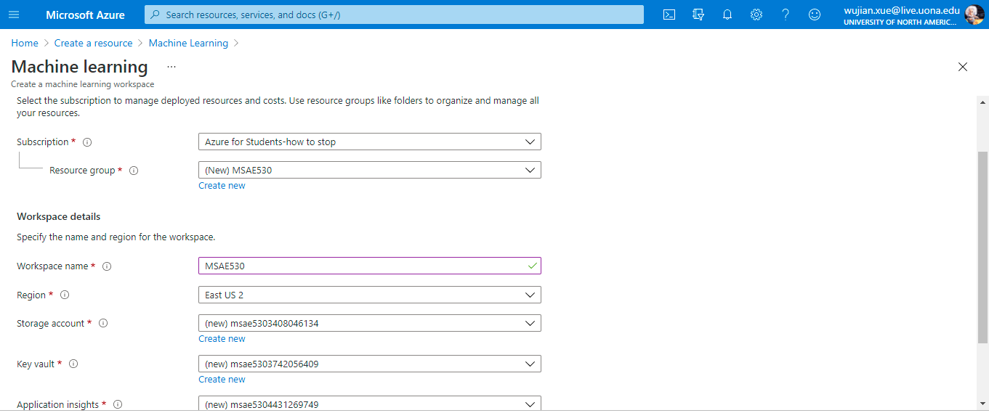

Create a machine learning workspace

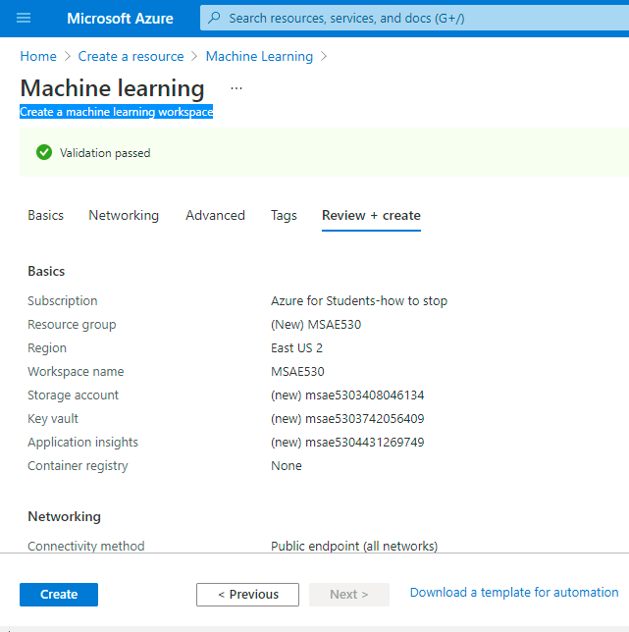

Finish the deployment

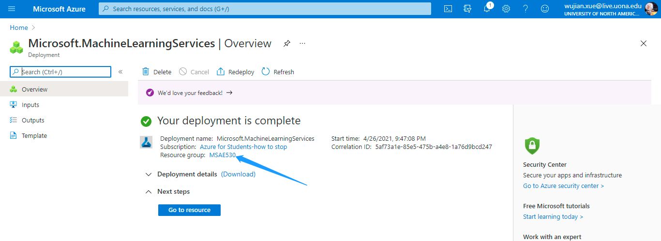

Launch Azure Machine Learning studio

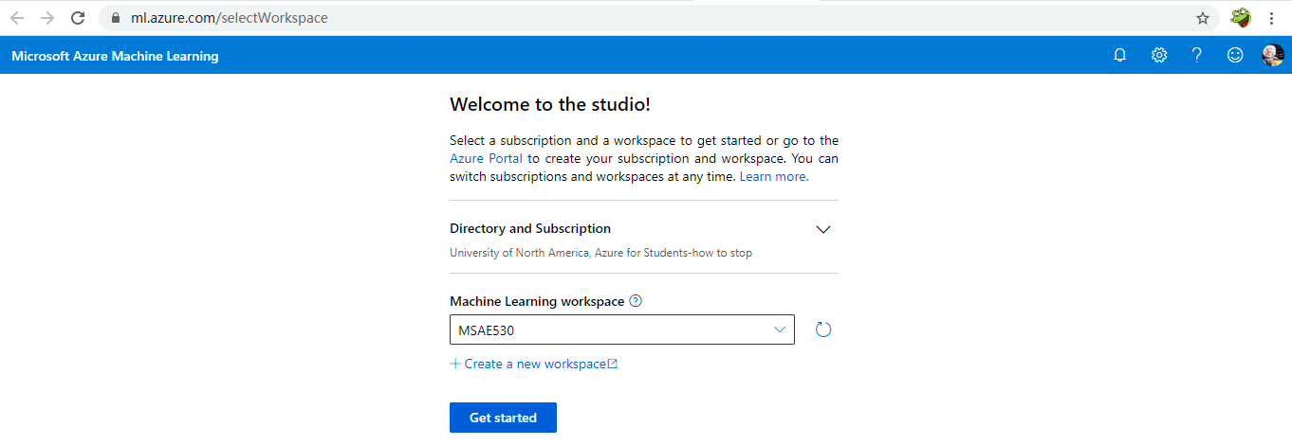

Azure Machine Learning studio is ready.

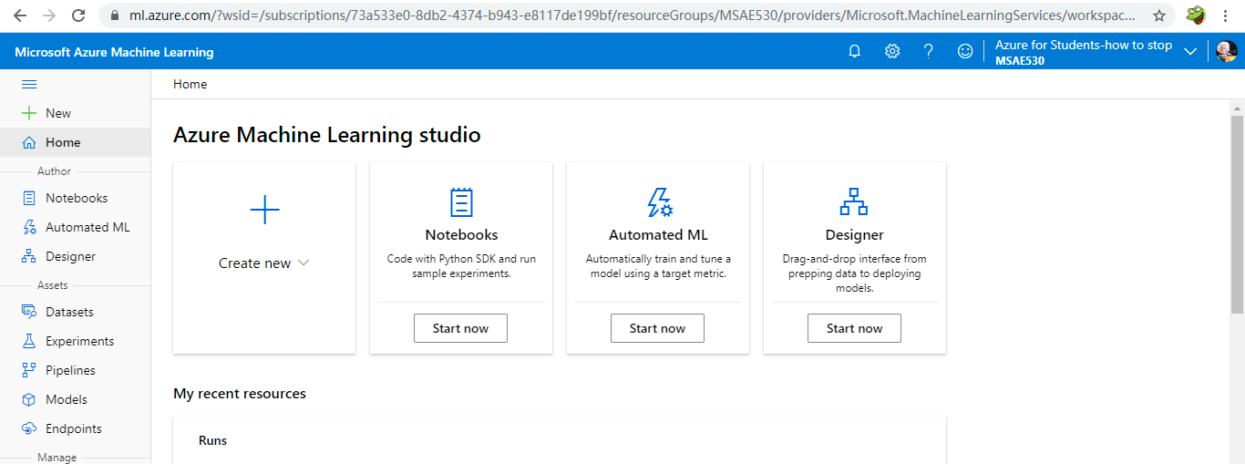

Click on the Notebooks

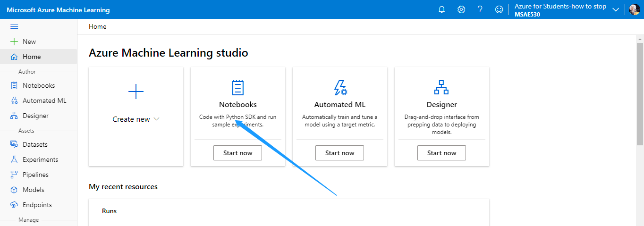

Create a compute

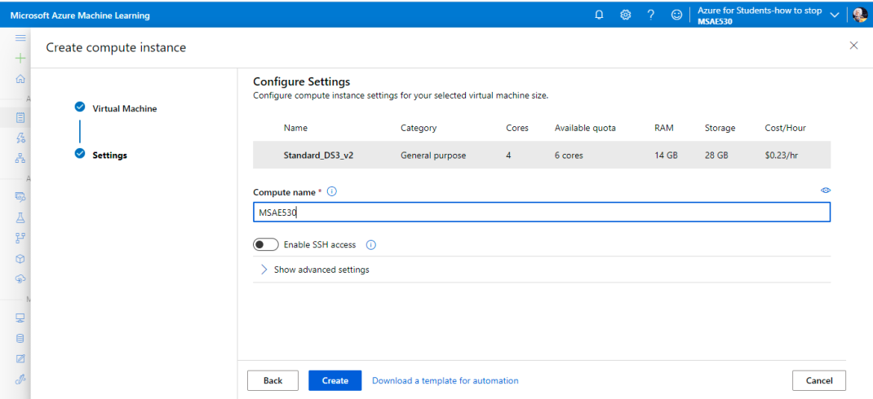

Write some Python code

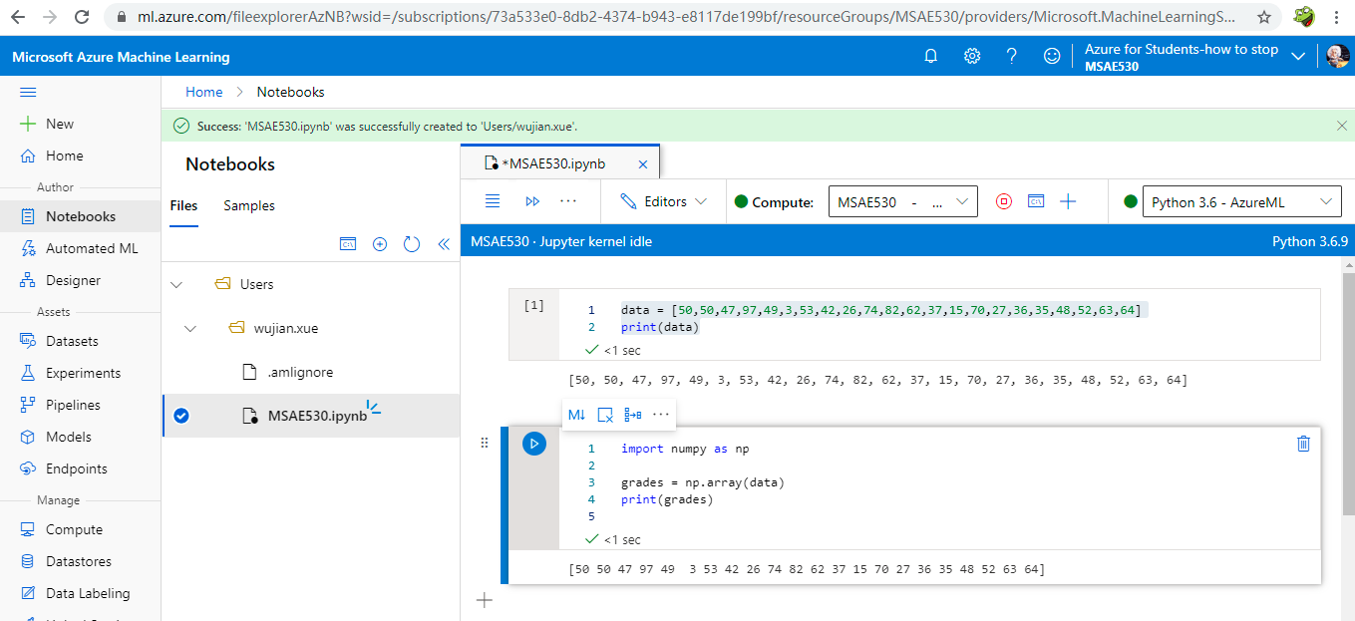

**5.Explain your experience about sign-up account and your thoughts using cloud service.**

As one of the most famous hi-tech companies, Microsoft Azure is very easy to sign up and start, especially you have Hotmail account. In addition, Azure is so generous that it offers $200 for new users and $100 for students. This will definitely attract more customers to Azure.

For the cloud services, I’d like to use Azure Machine Learning Studio as an example. I think it make machine learning models easier by changing programming languages such as Python to simply clicking on buttons. Many data manipulations steps are also becoming easier by avoiding lots of coding. However, users still need to understand the machine learning theories to explain the results.

Although now the market share for Azure is not number 1 in cloud computing, I think Azure will also be very popular in cloud computing. When using Azure, it’s more convenient to use other Microsoft products. This is the advantage of Azure to AWS.